**Application Installation Guide**

Step 1: Set-Up Php

1. Download and Install Xampp for php local application hosting

Step 2: Set-Up Composer

1. User command prompt/ Powershell or Git Bash to install Composer (Recommended: Visual Studio Code)
2. Command: php composer.phar install

Step 3: Set-up Database

1. Create a database with the name: epfdb

1. Create a table with the name: financial
2. Create the following fields in the table (financial)
   1. Id (int, 11, primary key, auto increment)
   2. first_name (varchar, 255)
   3. last_name (varchar, 255)
   4. date_of_birth (date)
   5. financial_month (varchar. 255)
   6. income (decimal, 65.2)
   7. expenses (decimal, 65.2)

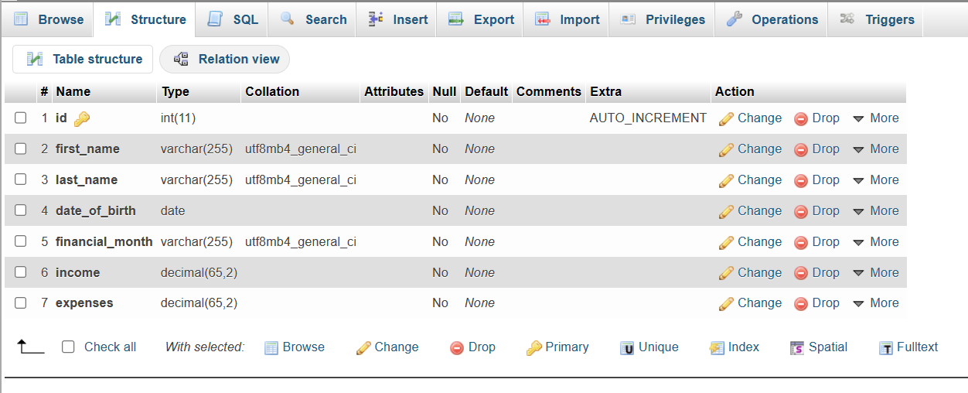

Step 4: Deploy the application

1. Place the application folder into htdocs of Xampp

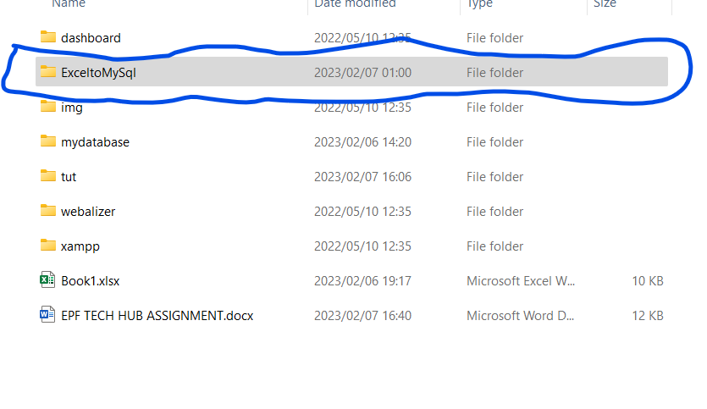

Step 4: Access the Application

1. User localhost on your browser
2. Click on the application name as per the folder on the htdocs
3. Below is the screen you will land on
4. Click upload in order to upload the excel file
5. Click view in order to view the data uploaded in the form of a graph



==End==